**DOCUMENTATION**

**SIMPLE GREETING APP**

**Description of the code:**

This Python code utilizes the Tkinter library to create a simple graphical user interface (GUI) application. The application prompts the user to enter their name through a labeled entry field. Upon clicking the "Greet" button, the program retrieves the entered name and dynamically generates a personalized greeting message. This message is then displayed within the application window. The GUI layout is managed using Tkinter's pack() method, ensuring a straightforward arrangement of widgets within the main window. Overall, the code provides a user-friendly interface for exchanging personalized greetings, demonstrating the basic functionalities of Tkinter for building interactive applications in Python.

**Benefits of the users:**

Enhanced User Experience: User interfaces simplify interactions between humans and machines, making tasks more intuitive and enjoyable. A well-designed user interface can enhance user experience by providing clear navigation, intuitive controls, and visually appealing designs.

Efficiency and Productivity: User interfaces streamline tasks, reducing the time and effort required to accomplish goals. Through intuitive layouts and easy-to-understand functionalities, users can navigate systems quickly and efficiently, leading to increased productivity.

Accessibility: User interfaces can improve accessibility by catering to diverse user needs and preferences. Features such as customizable settings, assistive technologies.

**Objectives:**

The objective of the provided Python code is to create a simple greeting app GUI using Tkinter. The code aims to facilitate user interaction by allowing individuals to input their name and receive a personalized greeting message. Through intuitive design and clear instructions, the interface ensures ease of use for users of all levels. By incorporating input collection, greeting message generation, and visual feedback mechanisms, the code aims to provide a seamless and enjoyable user experience. Ultimately, the objective is to create a user-friendly application that effectively fulfills the purpose of greeting users with a personalized message, enhancing their interaction with the software.

**Purpose:**

The purpose of this code is to create a simple graphical user interface (GUI) application using Python's Tkinter library. The application prompts the user to enter their name, and when they click the "Greet" button, it displays a greeting message with the entered name in a messagebox. It demonstrates the basic structure of creating a GUI application in Python for greeting users.

**Significance of the code/Features of the code:**

GUI Creation: It demonstrates how to create a basic graphical user interface (GUI) using Tkinter, which is a standard GUI toolkit for Python.

Widgets: It utilizes various Tkinter widgets such as Label, Entry, and Button to build the user interface components.

Event Handling: It shows how to handle events, such as button clicks, by associating a function (greet()) with the button's command attribute.

User Input: It allows users to input their name using the Entry widget and retrieves this input for further processing.

Messagebox: It uses the messagebox module from Tkinter to display informational or warning messages to the user.

Conditional Logic: It includes conditional logic to ensure that the user has entered their name before displaying the greeting message.

**THE CODE**

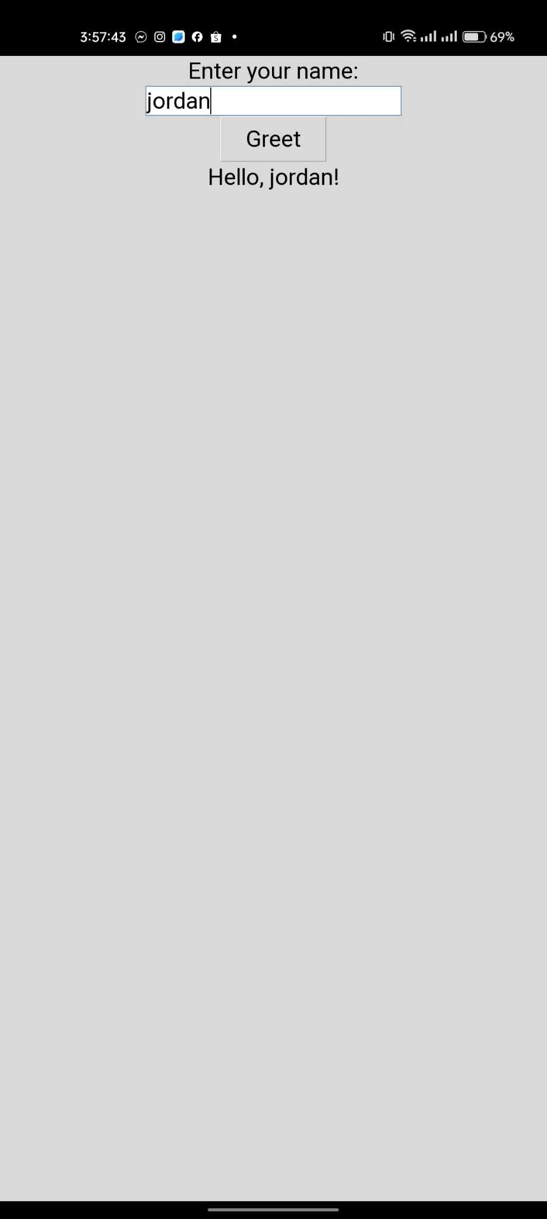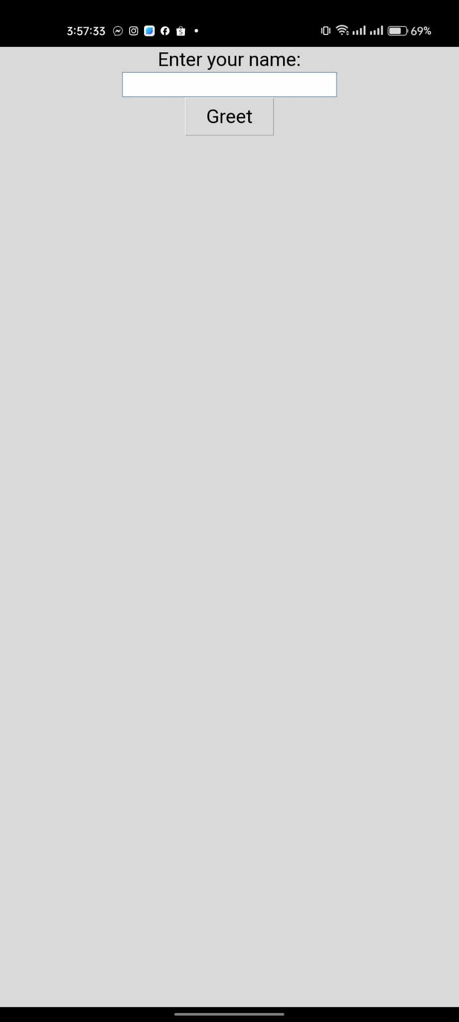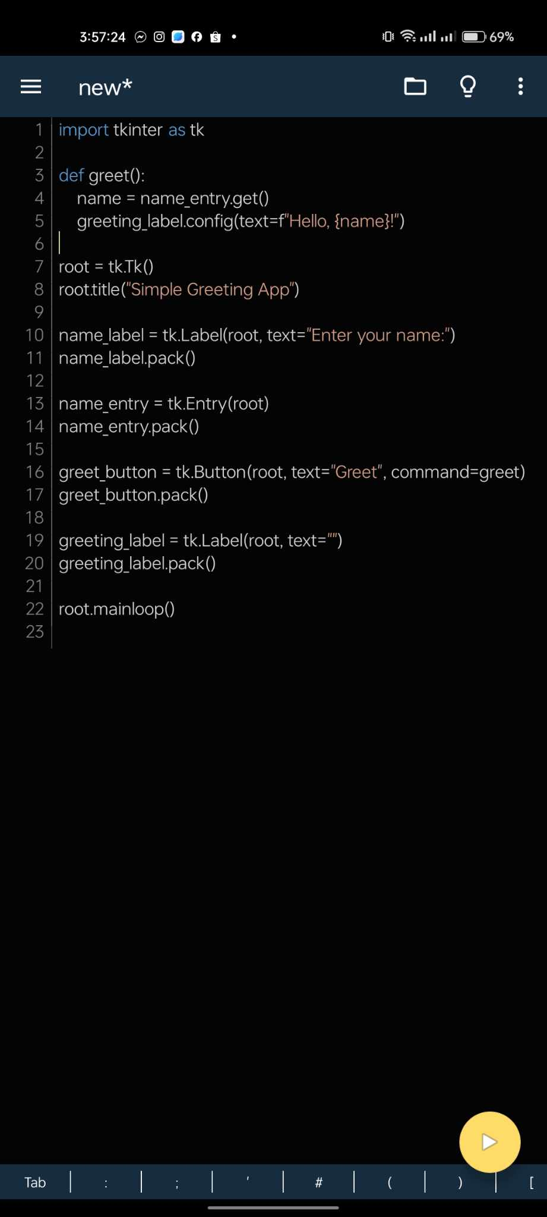

Curriculum Vitae

**PERSONAL INFORMATION**

**Name:** Jordan L. Gaytos

**Contact Number**: 09096227774

**Place of birth:** Surigao City

**Email Address:** Jordangaytos1@Gmail.com

**Age:**  21

**Address:** Doyos, Carrascal Surigao del Sur

**Nationality:** Filipino

**Religion:** Roman Catholic

**Civil Status:** Single

**Father’s Name:**  Decoroso L. Gaytos

**Mothers Name:**  Alenita L. Gaytos

**EDUCATIONAL BACKGROUND**

**Elementary:** Carrascal Central Elementary School

**Junior High School:** Carrascal National High School

**Senior High School:** Carrascal National Highschool